Description of the ETL pipeline:

I used 2 files:  
 main.py and sqlserver_connection.py

The way the etl works is first to import the needed packages:  
requests so get function could be applied, pandas for utilizing data frames, sqlserver_connection which  
is a file I created to define the connection to my SQL server db, for that I used sqlalchemy and urllib.

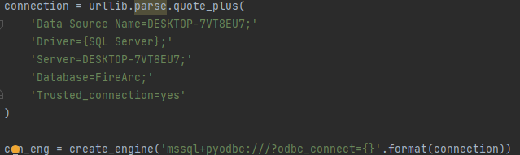  
to apply a connection SQL server and datetime so I'll be able to add datetime column.

The first action is to pick a json URL of the dataset through apidocs:  
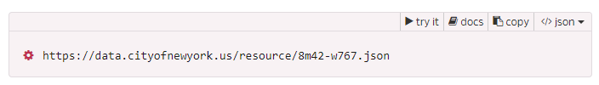

I used 'get' function out of requests and I limited the request to 10k rows to avoid ram overuse.  
Then I created a data frame out of that json in order to make it appropriate to be used in SQL.  
Next, I've added a datetime column to track inserted data.

Finally, I've use pandas to_sql function to stream the data to the db.  
